Project 9

Frederick Kelemen

2715308

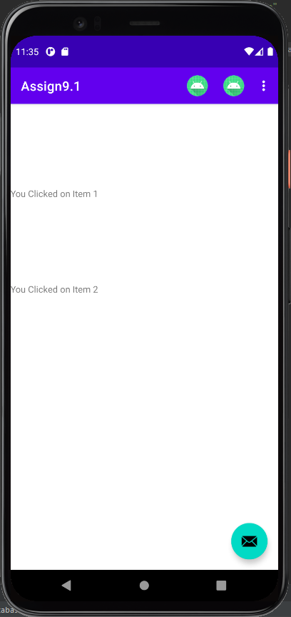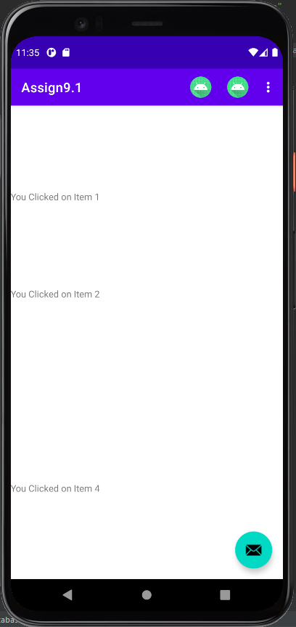In project 9 there are five buttons on the action bar the first four buttons cause the program to write into a textview, the textviews are evenly spaced throughout the display, the fifth button erases the contents of all 4 textviews.

